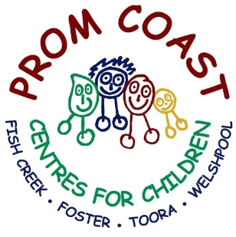
Careers @
Prom Coast Centres for Children
Early Childhood Educator
Early childhood educators work with children to support their play-based learning and early years growth and development.
Roles and responsibilities include:
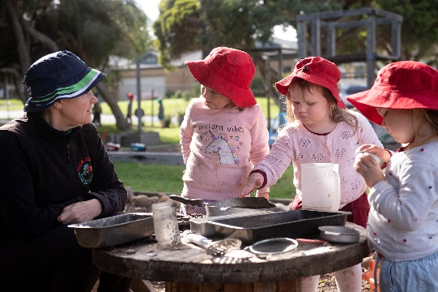
- plan and put in place programs based on individual children's needs
- prepare and supervise play and learning activities
- maintain a safe, clean and appealing environment
- observe and record children’s learning and development
- liaise with parents and other professionals
- support the participation of children with extra needs in the program
- help children with daily routines and promote health & safety
- guide and promote positive social interactions between children.
Qualifications
There are a range of qualifications and training opportunities that will open the door to a career as an early childhood educator. These include VET qualifications in education and care such as:
- Certificate III in Early Childhood Education and Care
- Diploma in Early Childhood Education and Care
Early Childhood Teacher
Early childhood teachers support the learning, development, health and wellbeing of young children, including babies and toddlers.
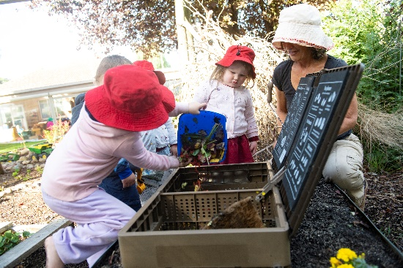
Roles and responsibilities include:
- plan activities to develop learning and development
- observe, assess and record children’s learning and development
- encourage children to question, explore and be aware of their world
- work as part of a team of professionals including nurses, educators and intervention specialists.
Qualifications
To become an early childhood educator, it takes 4 years of tertiary study.
The most common qualifications are:
- a 4-year undergraduate childhood qualification (e.g. Bachelor of Early Childhood Education)
- a ‘pathways’ course that allows those with an approved Certificate III or Diploma in children’s services to complete a degree in early childhood education.

